**Assignment 3**

**Problem 2**

**1.**

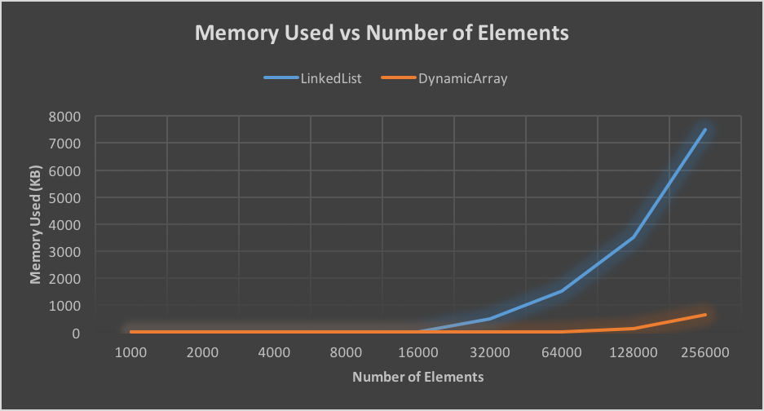

**2.**

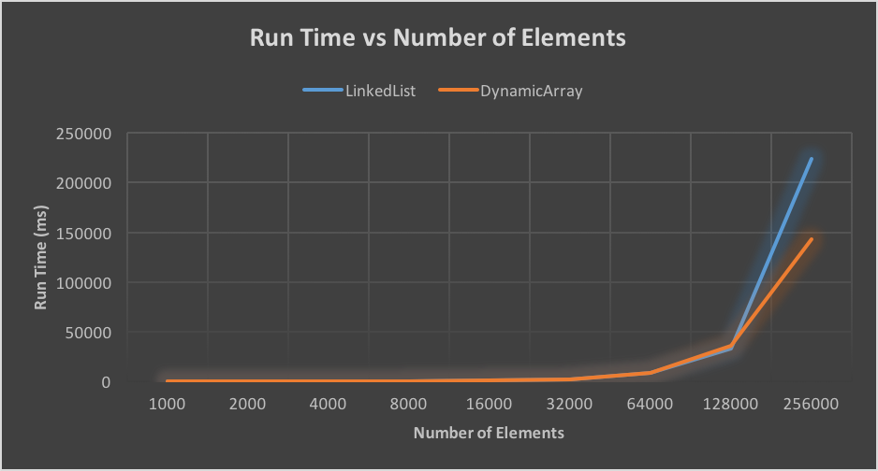

**Which of the implementations uses more memory? Explain why.**

The linked list uses more memory due to the fact that the structure contains a pointer for prev and next in each link. It also contains a sentinel which adds to the size.

**Which of the implementations is the fastest? Explain why.**

The dynamic array is implemented faster. This is due to the fact that the data stored in the array is stored in order. When the array is created memory is allocated in order, but in the linked list the memory can be scattered throughout the memory. Since the linked list contains a pointer in each structure it is not necessary for the structures to be in order.

**Would you expect anything to change if the loop performed remove() instead of contains()? If so, what?**

I would expect the runtimes to be faster for both implementations. For the contains function we could be required to scan the entire array or list in order to determine if the element is present. The remove function indicates either a link or index that we wish to remove. For the array we would delete the index and then shift the data, and for the linked list we would simply update the pointers and free the link. The array may take more time though if an earlier index is removed since we would be required to shift several additional elements.